1. **Explain the key features of Python that make it a popular choice for programming.**
2. It is widely used in industry.
3. It is widely used in data industry. For example, Data analytics, data scientists.
4. There are a lot of libraries where optimized and well written codes already exist.

For example, Pandas, numpi and c-bond etc. There are 137000 libraries in python.

1. Python community is very active and keeps growing.
2. Very easy to use.
3. Versatile ( Machine learning, Web development, Backed and front end development.
4. It can connect with other databases or other platforms as well.
5. **Describe the role of predefined keywords in Python and provide examples of how they are used in a program.**

These are the keywords or we can say code of instructions which are already present in the python language to give different type of outputs as per requirements.

For example, Print, type etc.

We can check the python keywords by using below command as shown in pic

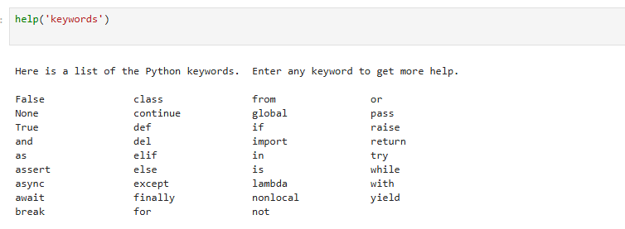

1. **Compare and contrast mutable and immutable objects in Python with examples.**

The word mutable itself indicates to change something.

In python we can change the elements present in the memory blocks. The elements whose elements we can change are known as ad mutable objects. For example, list.

The objects whose elements we can not change are known and immutable objects.

For example, string.

**For mutable objects**

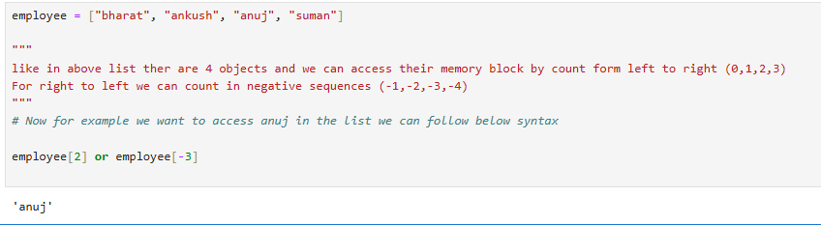

Now suppose we want to change “anuj” to “Rahul” then –

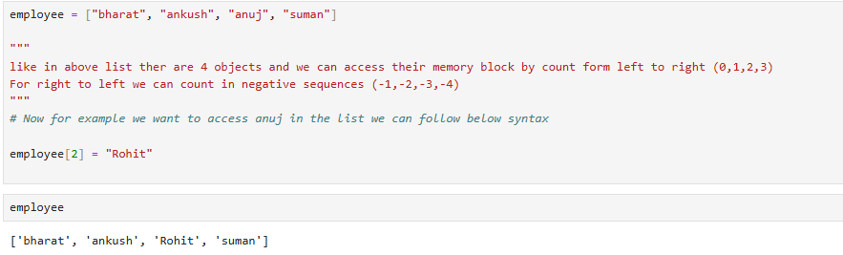

As we know that strings are immutable objects we can seen in below example

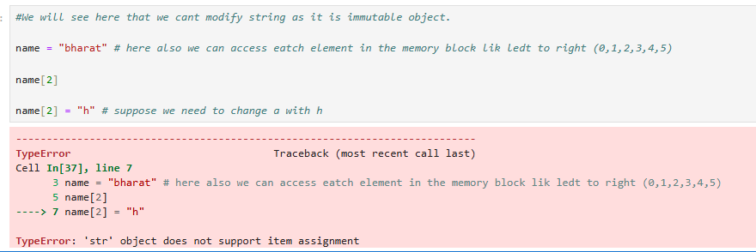

1. **Discuss the different types of operators in Python and provide examples of how they are used.**

There are different types of operators we use in python language.

1. Arithmetic operators (+ - * / % **)

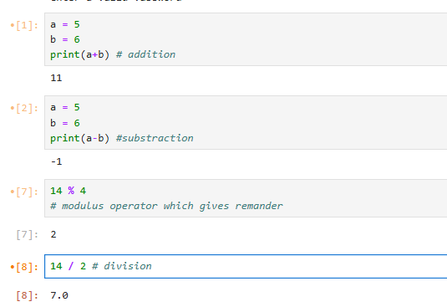

1. Comparison operators (== > < !* >= <=)

1. Logical operators (AND OR NOT)

1. Bitwise operators( AND& OR| XOR^ Left shift<< Right shift>>)
2. Membership operators( in not in)

1. Identity operators( is is not) A screenshot of a computer

   AI-generated content may be incorrect.
2. Assignment operators ( = += -= *= /=)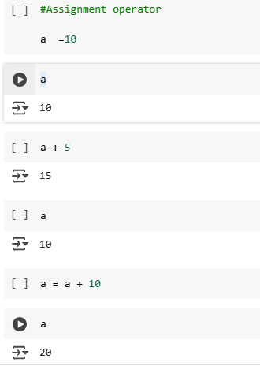
3. **Explain the concept of type casting in Python with examples.**

It means that we can change the data type.

For example, string to integer or string to float etc.

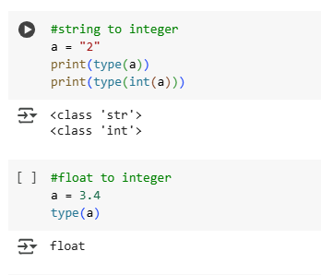

1. **How do conditional statements work in Python? Illustrate with examples**

Conditional statements are of 4 types

1. If
2. Else
3. Else if (elif)
4. Nested if else

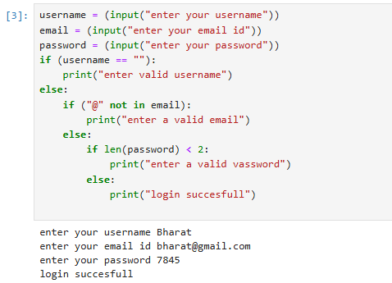

**7. Describe the different types of loops in Python and their use cases with examples.**

There are two types of loop in python (while, for). We can also use different statements like control, break and continue to manage the loops accordingly. While loop with break

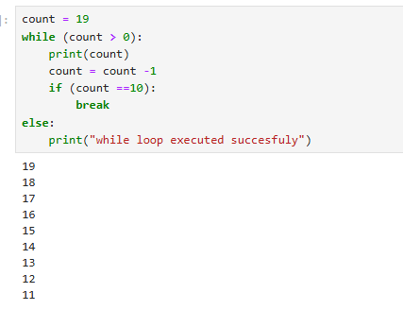

While loop with continue statement

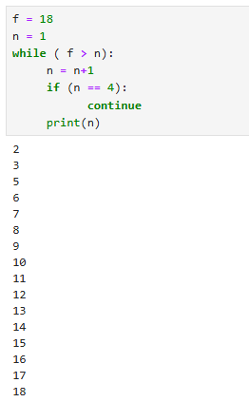

For with break statement

For with continue statement

